**Chapter 8: Energetics**

**All Lectures Uploaded on YouTube:**

[**https://tinyurl.com/fkm9-chemistry**](https://tinyurl.com/fkm9-chemistry)

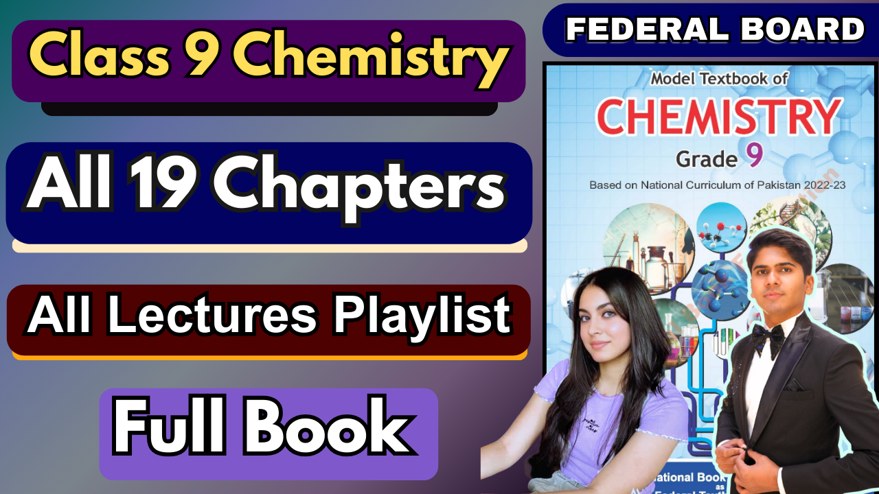

**Introduction to Chemical Energetics**

Chemical energetics is the study of energy changes that happen during chemical reactions.

**Energy is everywhere:** Every process in the universe, from what happens in our cells to reactions in a test tube, involves an energy change. Some processes (like burning fuel) **release** energy, while others (like melting ice) **require** energy.

The energy from chemical reactions is used to produce raw materials (like iron and steel) and to make useful products (like cars and buildings).

**8.1. Energy in Chemical Reactions**

Energy changes occur because chemical reactions involve **breaking old bonds** in the reactants and **forming new bonds** in the products.

∙ **Breaking Bonds:** Always **requires/consumes** energy (endothermic process).

∙ Forming Bonds: Always **releases** energy (exothermic process). **The Net Effect:**

If the **energy released** from forming new bonds is **greater** than the energy used to break old ones, there is a **net release of energy** (exothermic reaction).

If the **energy used** to break old bonds is **greater** than the energy released from forming new ones, there is a **net absorption of energy** (endothermic reaction).

**8.1.1. System and Surroundings**

To study energy changes, we define:

∙ **System:** The specific part of the universe we are focusing on (e.g., the chemicals reacting in a beaker).

∙ **Surroundings:** Everything else in the universe outside the system (e.g., the beaker, the air, the lab table).

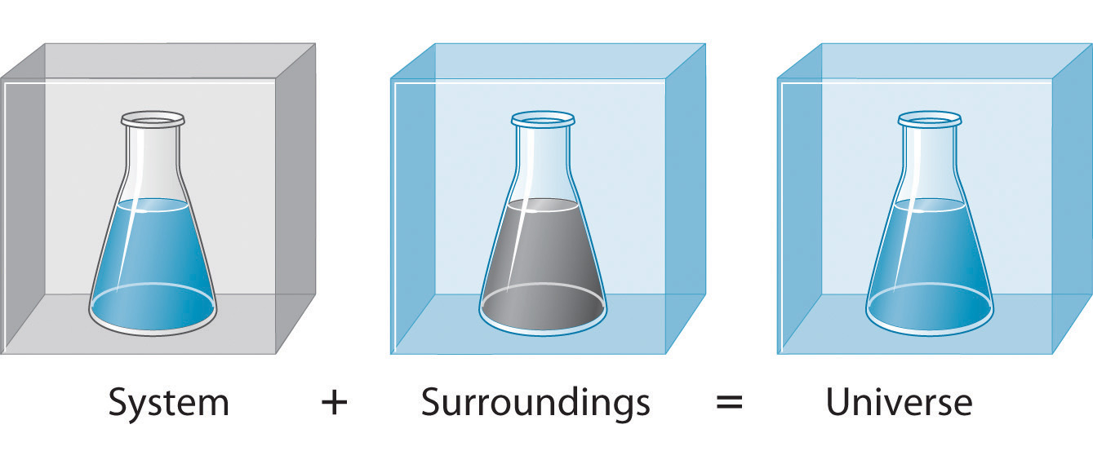

**Example:** For a reaction in a test tube, the reactants and products are the **system**, and the test tube and the air around it are the **surroundings**. Energy is exchanged between the system and its surroundings.

**8.2. Thermochemical Reactions**

A chemical reaction that proceeds with the evolution (release) or absorption (intake) of heat is a **thermochemical reaction**.

**Thermochemical Equation:** A balanced chemical equation that also shows the heat change of the reaction.

**Thermochemistry:** The branch of chemistry that deals with heat energy changes in chemical reactions.

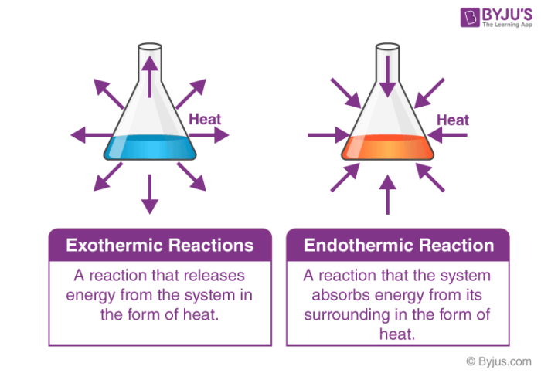

**8.2.1. Exothermic Reactions**

∙ Reactions that **release heat** to the surroundings.

∙ **Enthalpy Change (ΔH): Negative (ΔH < 0)**

∙ **Energy Flow:** Energy is transferred **from the system to the surroundings**. **Examples:**

1. C(s)+O2(g)→CO2(g) ΔHo=−393.5 kJ

2. 2H2(g)+O2(g)→2H2O(l) ΔHo=−571.6 kJ

**8.2.2. Endothermic Reactions**

∙ Reactions that **absorb heat** from the surroundings.

∙ **Enthalpy Change (ΔH): Positive (ΔH > 0)**

∙ **Energy Flow:** Energy is transferred **from the surroundings to the system**. **Examples:**

1. H2(g)+I2(g)→2HI(g) ΔHo=+53.8 kJ

**Classify as Exothermic or Endothermic:**

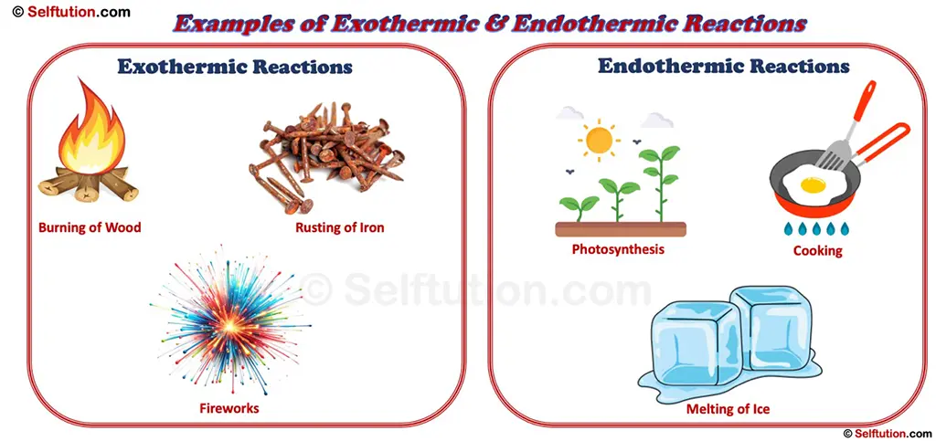

**(a) Freezing of water: Exothermic** (Energy is released when water molecules form a solid lattice).

**(b) Combustion of methane: Exothermic** (Burning fuel releases heat).

**(c) Sublimation of dry ice: Endothermic** (Solid CO₂ absorbs energy to become a gas).

**(d) H2O(l)→H2O(g) (Vaporization): Endothermic** (Energy is needed to convert liquid to gas).

**(e) Decomposition of limestone: Endothermic** (Heat is required to break down CaCO₃).

**8.3. Enthalpy of Reaction (ΔH)**

The amount of heat energy evolved or absorbed in a chemical reaction is called its **Enthalpy of Reaction**.

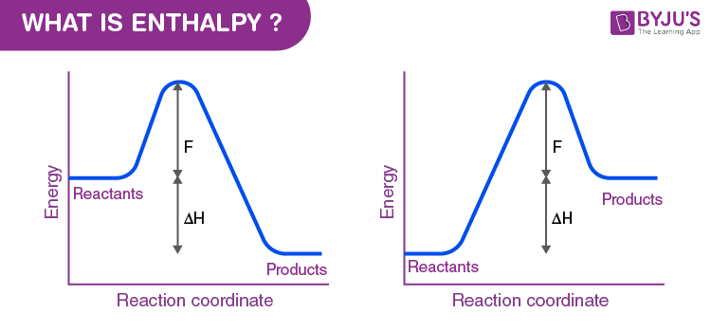

**The Sign of ΔH:**

o **ΔH is Negative:** Exothermic reaction.

o **ΔH is Positive:** Endothermic reaction.

**Standard Enthalpy Change (ΔH°):** This is the enthalpy change measured under standard conditions: **25°C (298 K)** and **one atmospheric pressure**.

**Example:** From the two reactions given, H2+I2→2HI with ΔHo=+53.8 KJ is **endothermic** because its ΔH is positive.

**8.4. Bond Energy and Bond Dissociation Energy**

**Bond Dissociation Energy:** The amount of energy **required to break** one mole of a specific chemical bond to form neutral atoms. **(Energy Absorbed)**

**Bond Energy:** The amount of energy **released when** neutral atoms form one mole of that same bond. **(Energy Released)**

**The Key to ΔH:** The difference between the total energy required to break all bonds in the reactants and the total energy released when all bonds in the products are formed determines the **enthalpy change (ΔH)** for the reaction.

**The Formula:**

ΔH= (Sum of Bond Dissociation Energies of Reactants) − (Sum of Bond Energies of Products)

**How to think about it:**

∙ If Energy to Break > Energy to Form → **ΔH is positive (Endothermic)**

∙ If Energy to Form > Energy to Break → **ΔH is negative (Exothermic)**

**Calculating Enthalpy from Bond Energies (A Practical Guide)**

This is a method to *predict* whether a reaction will be exothermic or endothermic and by how much, using the energy values of the bonds involved.

**Problem-Solving Strategy:**

1. **Write the Balanced Equation:** Ensure the equation is correct.

2. **State of Matter:** Assume all reactants and products are in the **gaseous state** for these calculations, as bond energies are defined for gaseous atoms.

3. **Apply the Formula:** Use the formula:

ΔH= (Sum of Bond Energies of Bonds BROKEN) − (Sum of Bond Energies of Bonds FORMED)

**Bonds Broken:** These are the bonds in the *reactants*. Breaking bonds *consumes energy*, so this is the energy *input* (positive value).

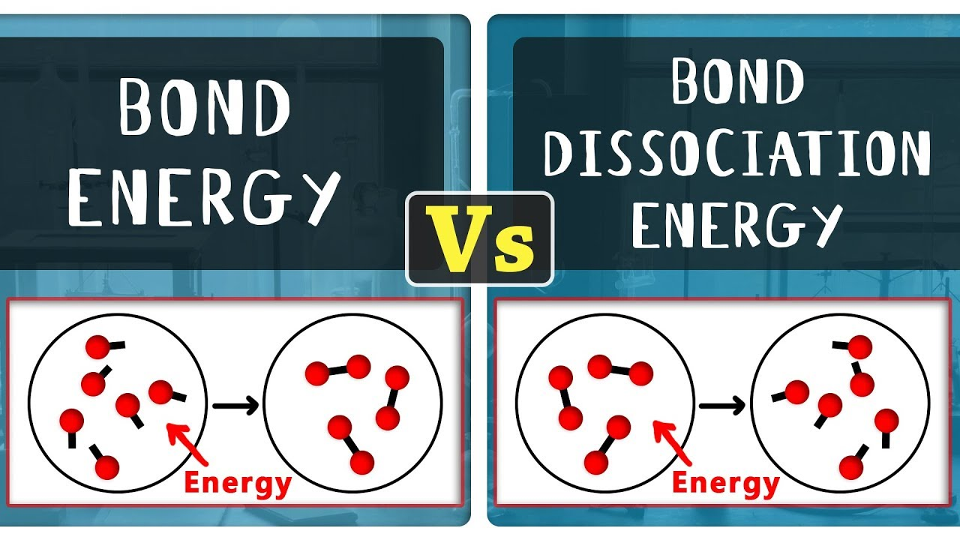

**Bonds Formed:** These are the bonds in the *products*. Forming bonds *releases energy*, so this is the energy *output* (negative value).

**Example 8.1: Reaction between Hydrogen and Iodine**

**Reaction:** H2(g)+I2(g)→2HI(g)

**Bonds Broken:** 1 H-H bond (436 kJ/mol) and 1 I-I bond (151 kJ/mol). **Bonds Formed:** 2 H-I bonds (2 × 299 kJ/mol = 598 kJ/mol).

**Calculation:**

ΔH=[436+151]−[598]

Δ*H*=[436+151]−[598]

ΔH=587−598=−11 kJ/mol

Δ*H*=587−59 8=−11kJ/mol

**Interpretation:** The negative sign confirms it is an **exothermic** reaction. The energy released in forming the new H-I bonds is slightly greater than the energy needed to break the original H-H and I-I bonds.

**Important Note:** The value calculated from bond energies is often an *estimate* because bond energies are average values and might vary slightly depending on the molecule. Experimental values can be more precise.

**8.5. Activation Energy (The "Energy Hump")**

The **minimum amount of extra energy** that colliding particles must have for a collision to be effective and result in a reaction.

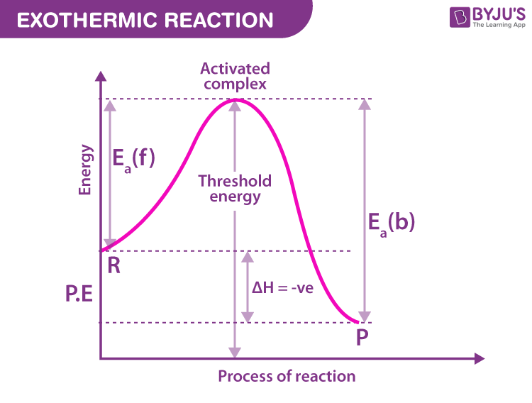

To overcome the repulsion between the electron clouds of reacting particles and to start breaking the existing bonds.

**Collision Theory:** For a reaction to happen, particles must:

1. **Collide with Sufficient Energy:** Their energy must be equal to or greater than the activation energy (Ea).

2. **Collide with Correct Orientation:** They must hit each other in the right way for new bonds to form.

**Effect on Reaction Rate:**

o **High Activation Energy** = **Slower Reaction** (Fewer particles have the required energy to overcome the large hump).

o **Low Activation Energy** = **Faster Reaction** (More particles have the required energy to overcome the small hump).

**Analogy:** Pushing a boulder over a hill. The energy you need to get it to the top of the hill is the activation energy. Once it's over the top, it rolls down on its own (the reaction proceeds, releasing energy if exothermic).

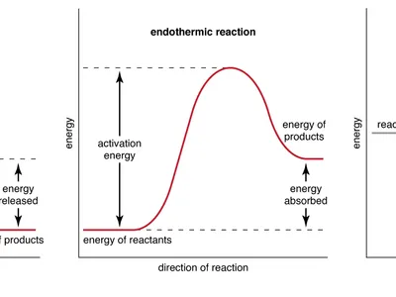

**8.6. Catalyst (The Reaction Helper)**

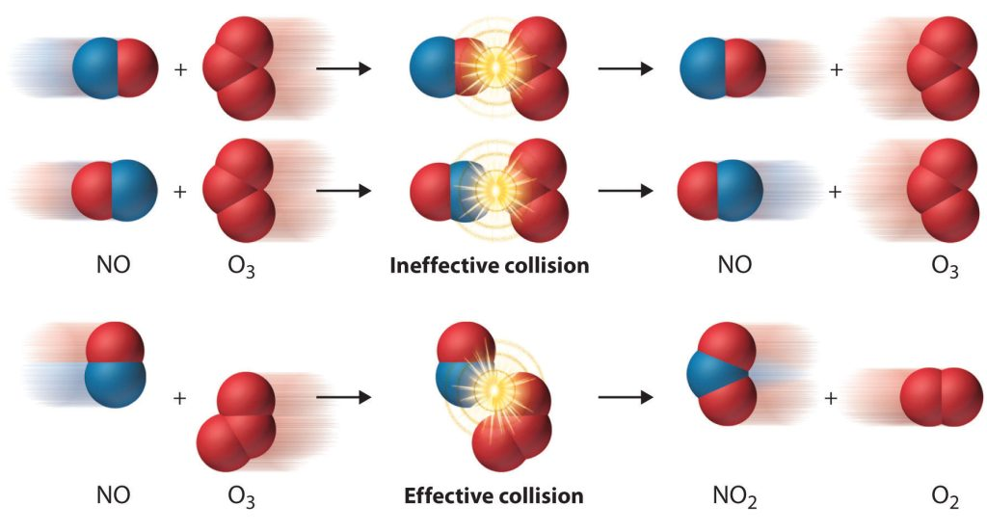

A substance that **speeds up a chemical reaction** but remains **chemically unchanged** at the end.

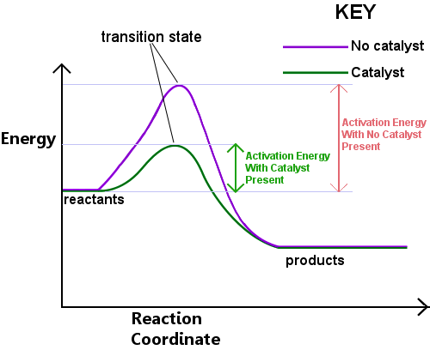

A catalyst provides an **alternative pathway** for the reaction that has a **lower activation energy**.

∙ **Lowers the activation energy.**

∙ **Increases the reaction rate** (more collisions become effective because the "energy hump" is smaller).

∙ It is **not consumed** in the reaction.

∙ It does **not change the enthalpy (ΔH)** of the reaction. (The starting and ending energy levels are the same; it just makes it easier to get there).

∙ It does **not initiate** a reaction that isn't already possible.

∙ **Biological Catalysts:** In living organisms, catalysts are called **enzymes**.

**8.7. Respiration (Energetics in Biology)**

Respiration is the **biochemical process** in which energy is released from food (like glucose) inside the cells of living organisms.

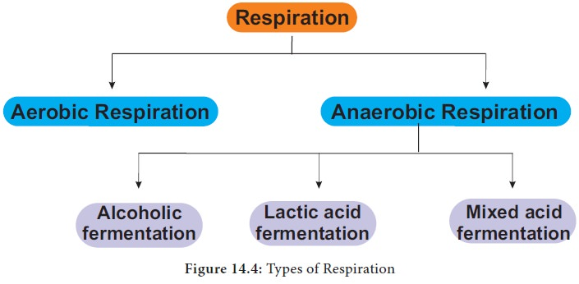

**It's Exothermic!** This process involves the oxidation of glucose, which releases energy. Therefore, respiration is an **exothermic reaction**.

**Types of Respiration:**

**Aerobic Respiration:**

Requires Oxygen.

Complete Breakdown: Glucose + Oxygen → Carbon Dioxide + Water + A Lot of Energy

This is the main, most efficient energy-producing process.

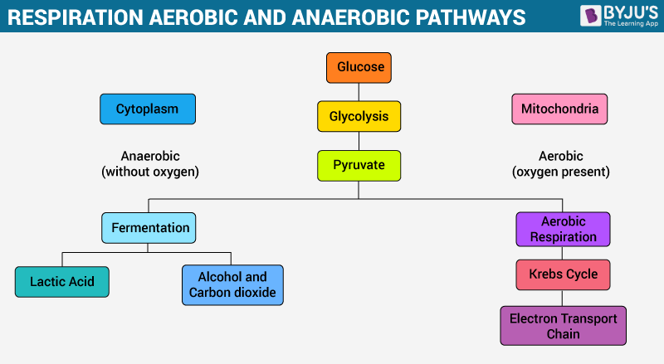

**Anaerobic Respiration:**

Does NOT require Oxygen.

Incomplete Breakdown: Glucose → Lactic Acid + A Little Energy Used when oxygen is low (e.g., intense exercise). Much less efficient.

**Role of Lipids:** Lipids (fats) are the body's **long-term energy reserve**. They store very large amounts of energy. When glucose runs out during prolonged activity, the body oxidizes lipids to release energy.

